DATA BASE TABLE

Tasks 1: Database Design:

----------------------------

1.) CUSTOMER

CREATE TABLE Customers (

customer_id INT PRIMARY KEY,

first_name VARCHAR(50) NOT NULL,

last_name VARCHAR(50) NOT NULL,

DOB DATE,

email VARCHAR(100),

phone_number VARCHAR(20)

);

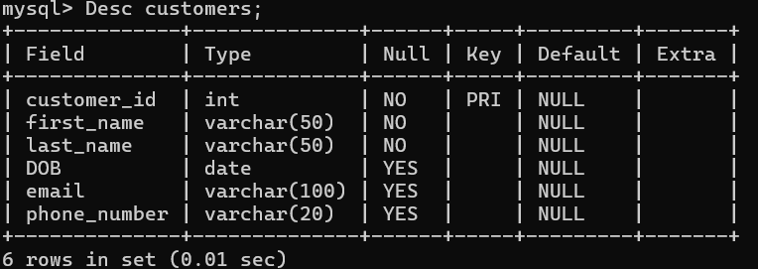

2.) Accounts

CREATE TABLE Accounts (

account_id INT PRIMARY KEY,

customer_id INT,

account_type VARCHAR(50) NOT NULL Default 'Saving',

balance DECIMAL(10, 2) DEFAULT 0.00,

CONSTRAINT Accounts_customer_id_fk FOREIGN KEY (customer_id) REFERENCES Customers(customer_id)

);

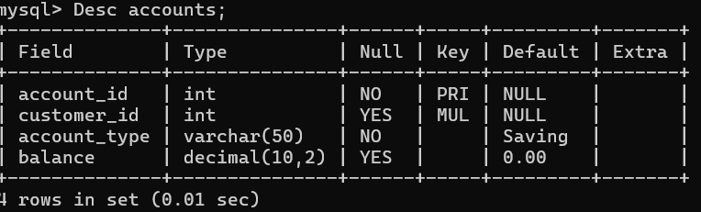

3.) Transactions

CREATE TABLE Transactions (

transaction_id INT PRIMARY KEY,

account_id INT,

transaction_type VARCHAR(50) NOT NULL DEFAULT 'Deposits',

amount DECIMAL(10, 2) NOT NULL,

transaction_date DATE ,

CONSTRAINT Transactions_account_id_fk FOREIGN KEY (account_id) REFERENCES Accounts(account_id));

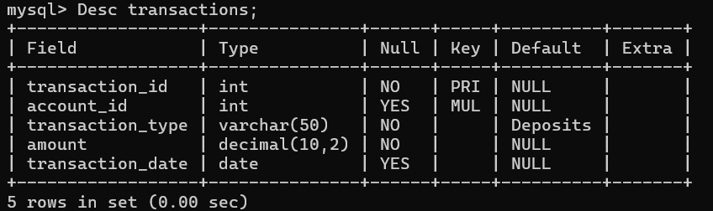

Tasks 2:

--------

1. Insert at least 10 sample records into each of the following tables.

1.)Customers

2.)Accounts

3.)Transactions

INSERTING DATA INTO CUSTOMERS TABLE

------------------------------------

INSERT INTO Customers (customer_id, first_name, last_name, DOB, email, phone_number)

VALUES

(1, 'John', 'Doe', '1990-05-15', 'john.doe@example.com', '123-456-7890'),

(2, 'Jane', 'Smith', '1985-11-23', 'jane.smith@example.com', '234-567-8901'),

(3, 'Robert', 'Johnson', '1978-07-10', 'robert.johnson@example.com', '345-678-9012'),

(4, 'Emily', 'Davis', '1992-03-05', 'emily.davis@example.com', '456-789-0123'),

(5, 'Michael', 'Brown', '1980-09-22', 'michael.brown@example.com', '567-890-1234'),

(6, 'Jessica', 'Miller', '1995-12-30', 'jessica.miller@example.com', '678-901-2345'),

(7, 'David', 'Wilson', '1988-06-18', 'david.wilson@example.com', '789-012-3456'),

(8, 'Sarah', 'Moore', '1993-08-12', 'sarah.moore@example.com', '890-123-4567'),

(9, 'James', 'Taylor', '1975-04-02', 'james.taylor@example.com', '901-234-5678'),

(10, 'Laura', 'Anderson', '1991-10-27', 'laura.anderson@example.com', '012-345-6789');

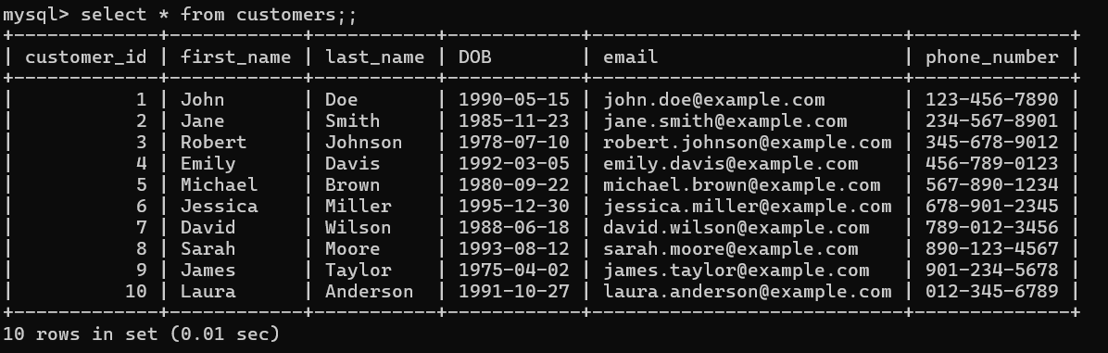

INSERING DATA INTO ACCOUNTS TABLE

----------------------------------

INSERT INTO Accounts (account_id, customer_id, account_type, balance)

VALUES

(101, 1, 'savings', 1500.00),

(102, 2, 'current', 2500.50),

(103, 3, 'zero_balance', 0.00),

(104, 4, 'savings', 5000.75),

(105, 5, 'current', 1200.30),

(106, 6, 'savings', 300.25),

(107, 7, 'current', 4200.90),

(108, 8, 'zero_balance', 0.00),

(109, 9, 'savings', 900.10),

(110, 10, 'current', 1600.45);

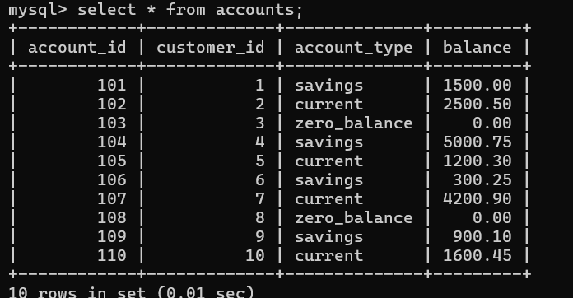

INSERTING DATA INTO TRANSACTIONS TABLE

----------------------------------------

INSERT INTO Transactions (transaction_id, account_id, transaction_type, amount, transaction_date) VALUES

(1, 101, 'deposit', 100.00, DEFAULT),

(2, 101, 'withdrawal', 50.00, DEFAULT),

(3, 102, 'transfer', 200.00, DEFAULT),

(4, 103, 'deposit', 300.00, DEFAULT),

(5, 102, 'withdrawal', 150.00, DEFAULT),

(6, 104, 'deposit', 500.00, DEFAULT),

(7, 105, 'transfer', 250.00, DEFAULT),

(8, 106, 'withdrawal', 100.00, DEFAULT),

(9, 107, 'deposit', 400.00, DEFAULT),

(10, 108, 'transfer', 600.00, DEFAULT);

